Разновидности композитных панелей
Product >> SOLID SERIES >> All sort Total 23 prod
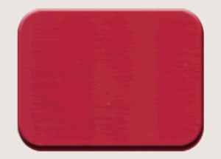  Model：ZM-14  Name：China red | 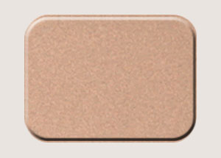  Model：ZM-28  Name：Brown copper | 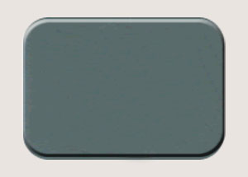  Model：ZM-27  Name：China Bank Gray
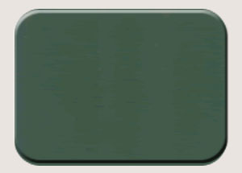Model：ZM-21  Name：Post Green | 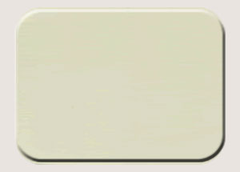Model：ZM-04  Name：lvory White | 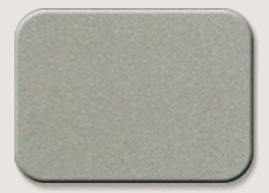Model：ZM-20  Name：Silver Champagne
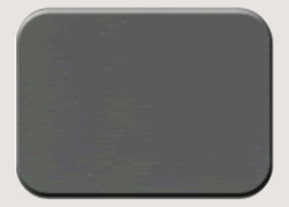Model：ZM-07  Name：Mouse Gray | 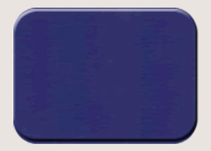Model：ZM-13  Name：Ultramarine Blue | 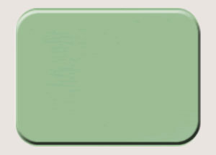Model：ZM-25  Name：Bloom white

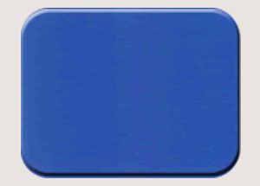  Model：ZM-12  Name：Light Blue |   Model：ZM-23  Name：Apple Green |  | 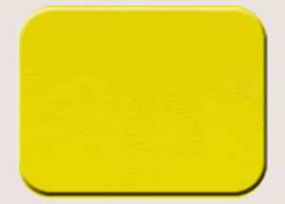Model：ZM-08  Name：Citrine
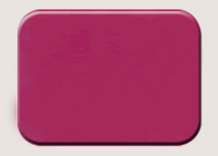  Model：ZM-17  Name：Rose Red | 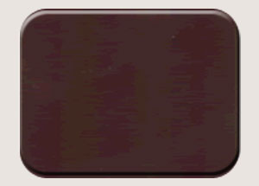  Model：ZM-16  Name：Coffce |  | 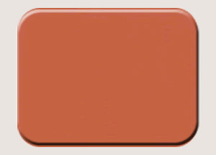Model：ZM-15  Name：Orange Red
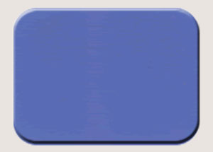  Model：ZM-11  Name：Lake Blue | 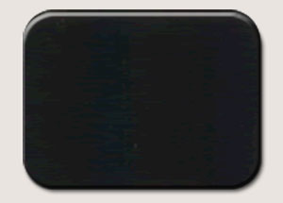  Model：ZM-26  Name：Black |  | 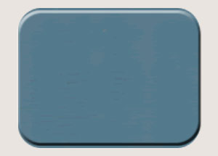Model：ZM-24  Name：Finland Green
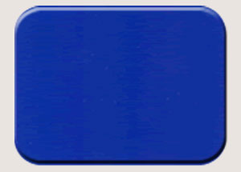  Model：ZM-10  Name：Telecom Blue |  | 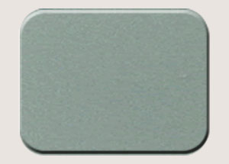  Model：ZM-18  Name：Jade Silver |  | 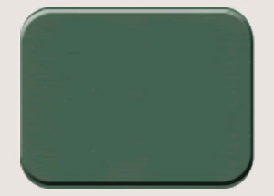  Model：ZM-22  Name：Emerald
  Model：ZM-03  Name：Pure white |  | 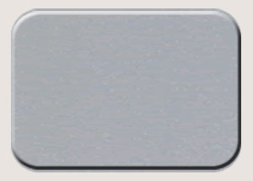  Model：ZM-02  Name：Silver

Product >> DREAM SERIES >> All sort Total 8 prod
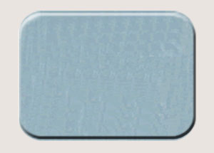Model：ZM-30  Name：Silver wire drawing | 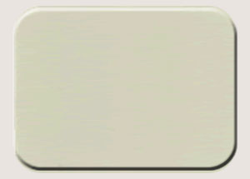Model：ZM-06  Name：Matt milky-white | 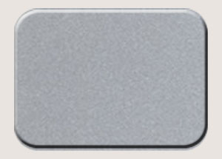Model：ZM-01  Name：Shining silver
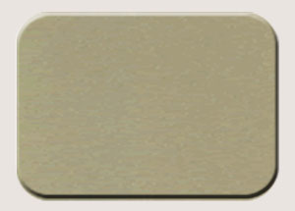Model：ZM-09  Name：Shiny Golden | 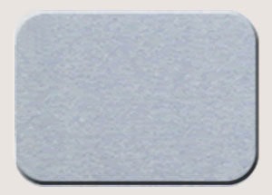Model：ZM-05  Name：Original aluminium color | 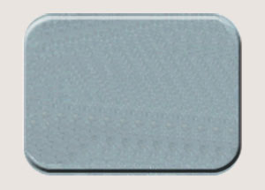Model：ZM-18  Name：Jade Silver
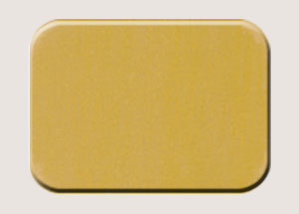Model：ZM-29  Name：golden wite drawing | 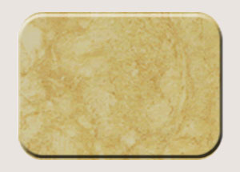Model：ZM-36  Name：Perlato Svevo

Product >> WOODGRAINS SERIES >> All sort Total 4 prod
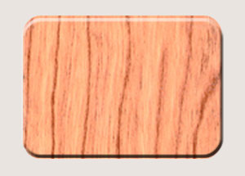Model：ZM-42  Name：Cherry | 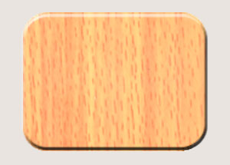Model：ZM-40  Name：Red Beech | 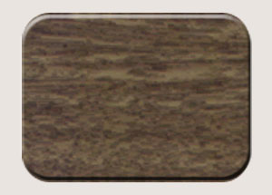Model：ZM-39  Name：Americanwainut
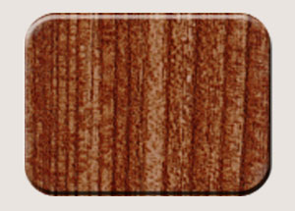Model：ZM-41
Name：Maple

MARBLE SERIES >> All sort
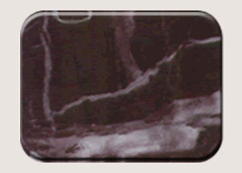Model：ZM-33  Name：Rosso Antico Dttalia | 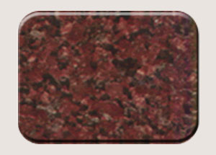Model：ZM-35  Name：New lmperial Red | 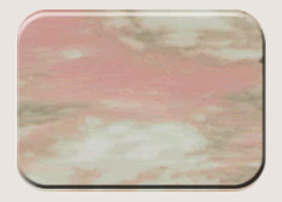Model：ZM-34  Name：Rosso Norvegian
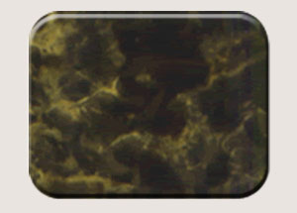Model：ZM-32  Name：Black golden patterns | 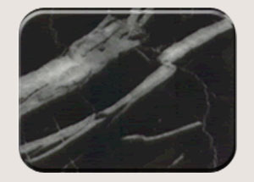Model：ZM-31  Name：Black and white silver | 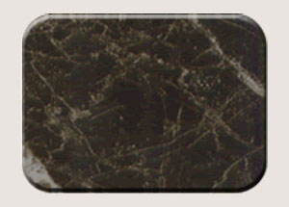Model：ZM-38  Name：Emperador Dark
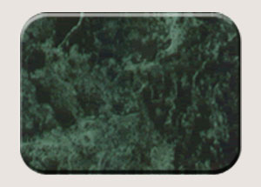Model：ZM-37
Name：Dark green

